**DAILY ONLINE ACTIVITIES SUMMARY**

|  |  |  |  |  |  |  |  |  |
| --- | --- | --- | --- | --- | --- | --- | --- | --- |
| **Date:** | **4-6-2020** | | | | | **Name:** | **poojashree** | |
| **Sem & Sec** | **8th sem A sec** | | | | | **USN:** | **4al16cs065** | |
| **Online Test Summary** | | | | | | | | |
| **Subject** | | **sms** | | | | | | |
| **Max. Marks** | | **60** | | **Score** | | | **60** | |
| **Certification Course Summary** | | | | | | | | |
| **Course** | **Artificial intelligence** | | | | | | | |
| **Certificate Provider** | | | **Great learning academy** | | **Duration** | | | **7hr** |
| **Coding Challenges** | | | | | | | | |
| **Problem Statement:**   1. **Program to print full pyramid using star pattern** 2. **Program to print inverted pyramid using star pattern** | | | | | | | | |
| **Status:completed** | | | | | | | | |
| **Uploaded the report in Github** | | | | | **yes** | | | |
| **If yes Repository name** | | | | | **Poojashree** | | | |
| **Uploaded the report in slack** | | | | | **yes** | | | |

**Online test**

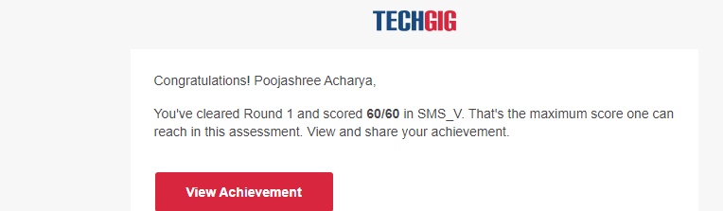

**Certification course**

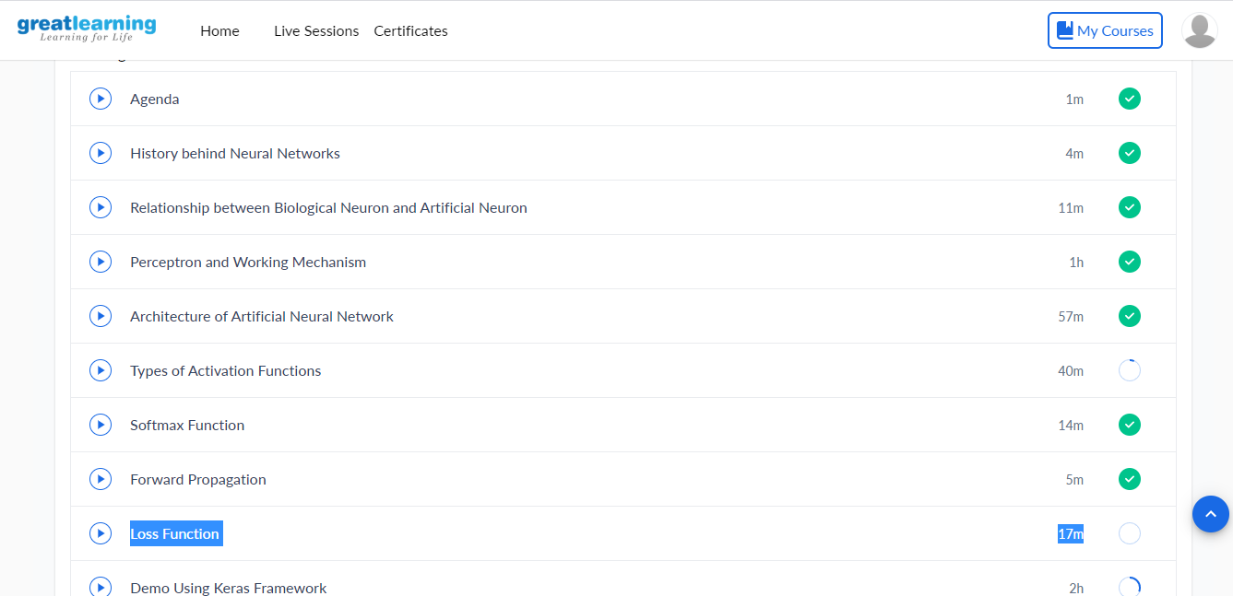

**Coding**

**Program 1**

**// C program to print full pyramid pattern using stars**

**#include <stdio.h>**

**int main()**

**{**

**int i, j, n, k = 0;**

**scanf(“%d”,&n);**

**for(i = 1; i <= n; ++i, k = 0)**

**{**

**for(j = 1; j <= n – i; ++j)**

**{**

**printf(” “);**

**}**

**while(k != 2 * i-1)**

**{**

**printf(“* “);**

**++k;**

**}**

**printf(“\n”);**

**}**

**return 0;**

**}**

**Coding 2**

**// C program to print inverted full pyramid pattern using stars**

**#include <stdio.h>**

**int main()**

**{**

**int i, j, n, k = 0;**

**scanf(“%d”,&n);**

**for(i=n; i>=1; --i)**

**{**

**for(j=0; j < n-i; ++j)**

**printf(” “);**

**for(j=i; j <= 2*i-1; ++j)**

**printf(“* “);**

**for(j=0; j < i-1; ++j)**

**printf(“* “);**

**printf(“\n”);**

**}**

**return 0;**

**}**